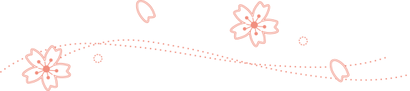
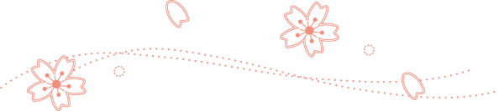
Change of Suicide Rate after the Great East Japan Earthquake in 2011 and Suicide Prevention Plan in Fukushima

1. Change of suicide rate after the Great East Japan Earthquake
(1) Change of suicide rate
In Japan, suicide rate has been decreasing for about 5 years, which continues after the Great East Japan Earthquake. In 3 prefectures that were most affected by the earthquake, the decrease was more steep.
earthquake
Note : There are two suicide statistics available. One is derived from the Vital Statistics and the other from the Police Statistics. This graph is based on the latter statistics.

(2) Rank order of suicide rate among all the prefectures in Japan
Although, as described above, the decrease of suicide rate in the most affected 3 prefectures were steep, the decrease speed seems to be slowing down after 2012. Along with that, the rank orders of suicide rate are rising in these 3 prefectures, up to the fourth worst rate in Fukushima, seventh in Miyagi, and second in Iwate, in the
latest statistics of suicide in 2014 (based on average rates from January to March).

Change of rank order of suicide rate in 3 prefectures (*) January-March in 2014
 | 2006 | 2007 | 2008 | 2009 | 2010 | 2011 | 2012 | 2013 | 2014(*)
Fukushima | No.9 | No.10 | No.14 | No.10 | No.18 | No.15 | No.21 | No.13 | No.4
Miyagi | No.27 | No.27 | No.22 | No.19 | No.20 | No.43 | No.29 | No.35 | No.7
Iwate | No.3 | No.5 | No.4 | No.4 | No.2 | No.4 | No.6 | No.2 | No.2

(3) Statistical analysis
a) Decrease of suicide rate after the earthquake
In Fukushima, mean suicide rate per year in 2012-2013 (after the earth quake) was significantly lower than that in 2006-2010 (before the earthquake) (t test between mean suicide rate in 20006-2010 and that in 2012-2013).

Comparison between suicide rates in 2006-2010 and 2012-2013 in Fukushima
 | mean | SD | t test
2006-2010 | 30.5 | 2.5 | p<0.01(mean suicide rate in 2012-2013 is significantly lower than that in 2006-2013)
2012-2013 | 23.5 | 0.5

b) Suicide rates in Fukushima are the same level of those in Japan
Suicide rates were tested by binominal distribution analysis for recent five years, which resulted in no statistical difference between suicide rates in Fukushima and in Japan. (data are not shown here).

2. Suicide rates in cities, towns and villages in Fukushima
The earthquake and the Fukushima 1st Nuclear Power Plant accident affected mostly the Seashore area in Fukushima. So, regional difference of suicide rates was evaluated with binominal distribution analysis. Maps below show cities, towns and villages with suicide rates that were significantly different form that of whole Japan.
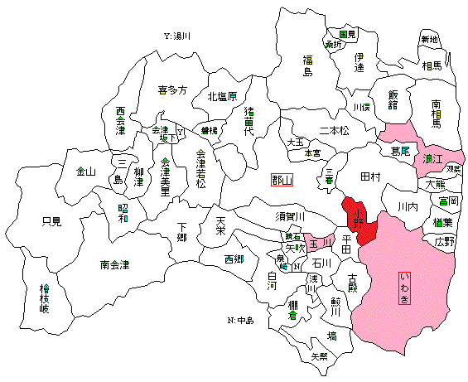
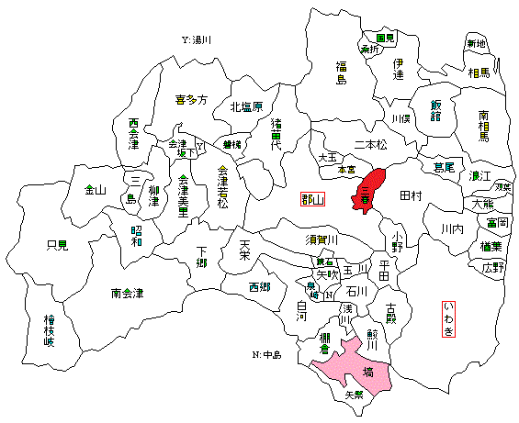
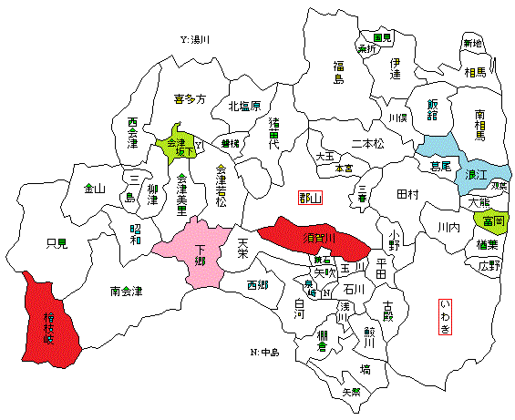
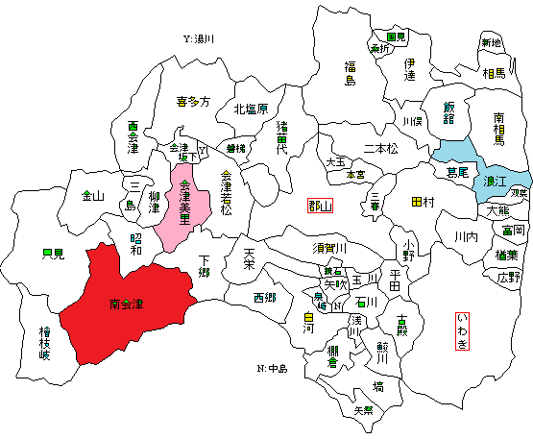
2011 (the year of the earthquake)
The Nuclear
Power Plant
2010
2013
2012
This map represents Fukushima prefecture. Seeshore area (Hamadori) locates in the right side of the maps. The Nuclear Power Plant locates on the center of this area. Aizu area locates in the left side and between these locates the Middle area (Nakadori).
2014(January-March)

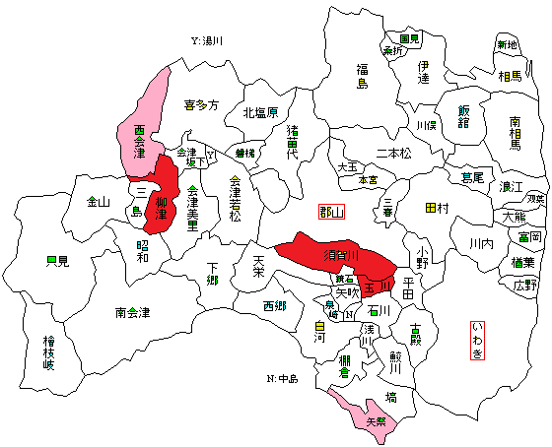

< significance level >
red: significantly high rate
pink: tendency of high rate
blue: significantly low rate
green: tendency of low rate

As you see, in several regions suicide rates were significantly high compared to that in whole Japan, but these regions were not in the Seashore area but in the Middle area or the Aizu area But you must aware that large amount of citizens in the Seashore area has taken refuge into other area and the number of suicides of refugee were not calculated.

3. Age and sex of suicide persons
【Whole Japan】Suicide rates of each age and sex group

Suicides of middle aged males greatly decreased recent years, which largely contribute to the decrease of all suicide.

Suicides by financial cause decreased, which seems to contribute to the decrease of suicide in middle aged males, stated above.

【Fukushima Prefecture】 Suicide rates of each age and sex group

Suicide rates of middle aged males decreased, also in Fukushima.
But suicide rates of over 80 years old were increased in both sex, and suicides of younger age showed random increase in 2013. These increases were not seen in whole Japan.

In Fukushima, suicides by financial cause decreased
But there is no data of why suicides of older age or younger age increased.

4. Summay
(1) Suicide rate has been
decreasing both in whole Japan and in Fukushima Prefecture. Decrease of suicides in middle aged males mostly contribute to this decrease, and this may be due to economic recovery.（The right graph shows remarkable rise of active opening rate, with prominent rise in Fukushima after the earthquake.）
(2) In 2013, suicide of older age and younger age increased. The cause of this increase is unknown. Factor other than financial one may be supposed.
(3) There is no evidence of increased rate of suicide in most affected seashore region. But more detailed data should be obtained, such as suicide rate of refugees. So far, there is no precise data obtainable.

5. Future suicide prevention plan
(1) The obtainable data shows no urge for suicide prevention plan.
So far, suicide rate in Fukushima does not show significant increase. But there appear some characteristic features of age related change. More scrutinized survey may be necessary.
(2) Effort for finding unknown factors
Suicide cause may be quite different from person to person. So it is useful to carefully examine the background of each suicide case, including inquiry to the bereaved families, thus finding unknown suicide factors. Thus obtained facts will facilitate more personalized help services which is necessary for suicide prevention.
(3) Cooperation
For recognizing and helping at risk persons with various problems, cooperation of supporters is necessary. Cooperation is also necessary for relieving supporters’ distress or fatigue. Some supporters are now under over-work due to psychological and substantial demand from survivors and perhaps from all over the Japanese society. In fact, over-work is itself an important risk factor for suicide. Supporters should take lead of relieving himself or herself from stress, and cooperation is the best strategy for attaining this.

